Analysis Report on Consensus effect on Stock Price (Miss Cases)

Dingming

1. Key Takeaways  
     
   For **Miss Down** situations:   
    Buy the stock on day 3 and sell it on day 14, yielding an average return of 2.7%.  
     
   For **Miss Up** situations:  
    Buy the stock on day 6 and sell it on day 19, yielding an average return of 1.8%.
2. Overall Summary  
   The analysis is conducted using data from the semiconductor sector, covering 67 equities: 20 from the U.S., 13 from the EU, 20 from developed Asia Pacific markets, and 14 from emerging Asia Pacific markets.

There are 319 miss cases and 105 situation 1 cases. The observation window is set to 20 days after the earnings announcement, and only cases where the earnings miss exceeds 10% are included in the analysis.  
  
Situation 1 takes up 1/3 within miss situations (Situation 1 to 4 combined) and 2/3 within miss down situations (situation 1 to 3). This distribution is similar to beat cases.

1. The Distribution of Peak dates (Situation 1)

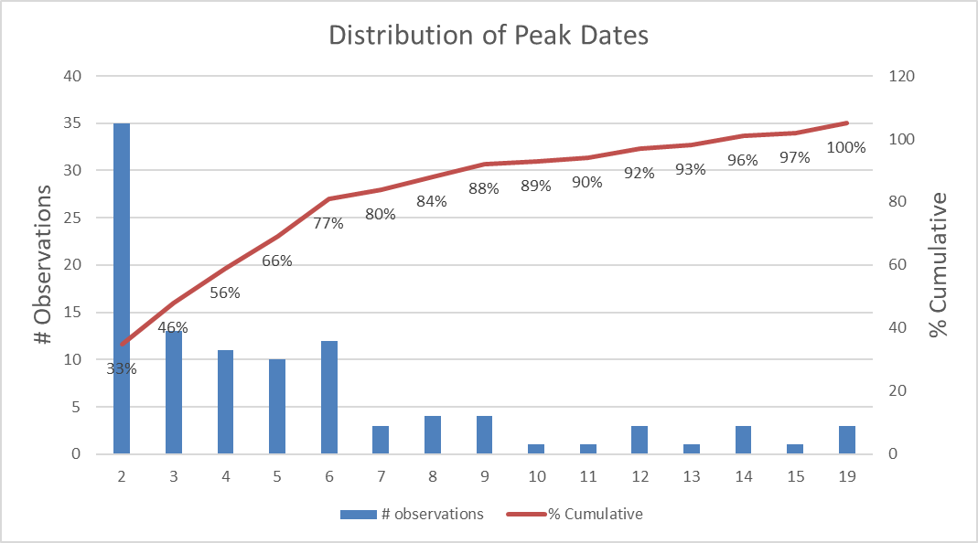



Peaks most frequently occur on day 2, with the majority distributed between days 2 and 6.

Notably, 50% of the samples rebound to day-1-level on day 2.



Average Day1 return is -4.69%.



1. Average Cumulative Return Analysis (Situation 1 to 3 combined)  
   There one strategy for capitalizing on miss situations:

* Buy the stock on day 3 and sell it on day 14, yielding an average return of 2.68%.

Although there are three different patterns identified under miss-down scenarios, it is practically difficult to distinguish among them during live trading. This is because we cannot accurately predict when the stock will reach its peak or begin to rebound. Therefore, I used all the miss down cases for analysis.





1. Analysis on Miss Up situations

There are 147 cases in miss up situations. The figure of cumulative return is as shown below. From this figure it can be observed that the average cumulative return reaches the lowest on Day 5 and highest on Day 19.

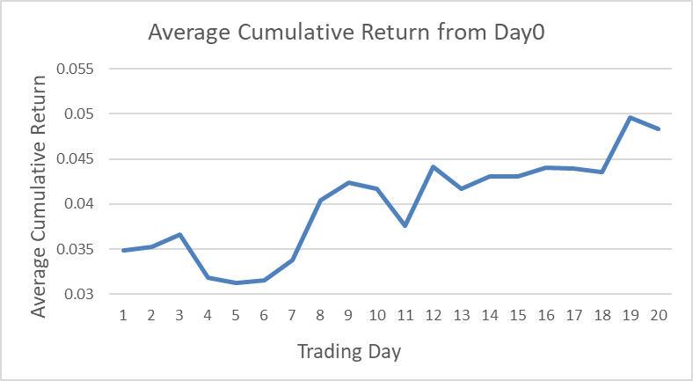

Therefore, one potential strategy is to buy the stock on day 6 and sell it on day 19.

The average cumulative return from day 6 to each subsequent day is illustrated in the figure below. As shown, this strategy yields an average cumulative return of 1.77%.

